Rayat Shikshan Sanstha’s
Dr. Babasaheb Ambedkar College, Aundh, Pune-67

College Development Committee

2022-23

Name of the  Committee Member | Designation | Photo
Hon. Mr.  Chandrakant Dalvi  ( I.A.S.) | Chairman  Representative of Hon. Chairman,  Rayat Shikshan Sanstha, Satara | 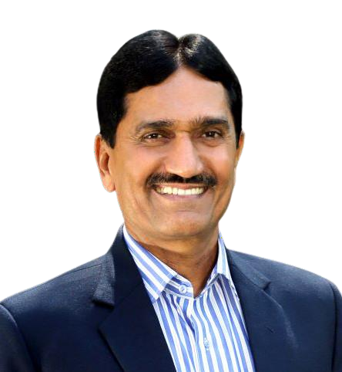
Hon. Prin. Dr. V. S. Shivankar | Member  Secretary, Rayat Shikshan Sanstha, Satara | 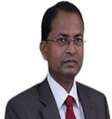
Hon. Adv. Ram Kandage | Member  Industrial Section | 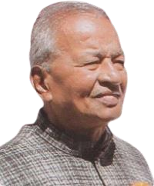
Hon. Mr. Dattatray Gaikwad | Member  Research Section | 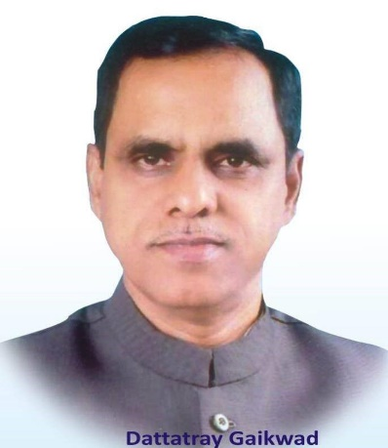
Hon. Sadashiv  (Bapu) Satav | Member  Education Section | 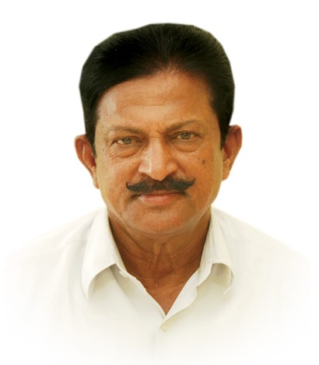
Hon. Mr. Tushar Jadhav | Member  Research Section | 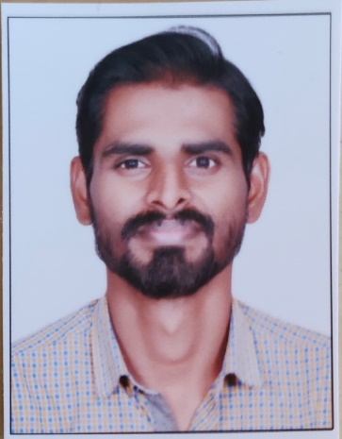
Prof. Bandopant Kamble | Member  Principal Representative | 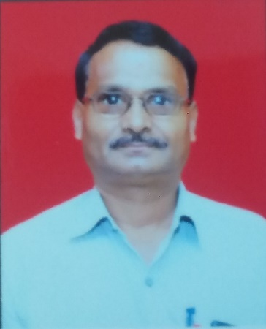
Prof. Bhimrao Patil | Member  Teacher representative | 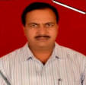
Prof. Tanaji Hatekar | Member  Teacher representative | 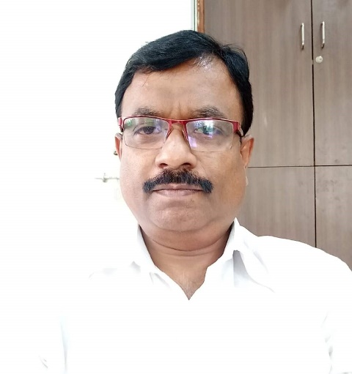
Prof. Dr. Reshma Divekar | Member  Teacher representative | 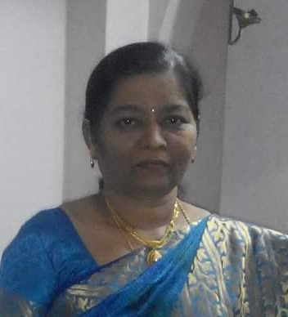
Dr. Savita Patil | IQAC coordinator | 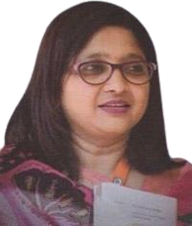
Mrs. Anuradha Dharashivkar | Staff representative | 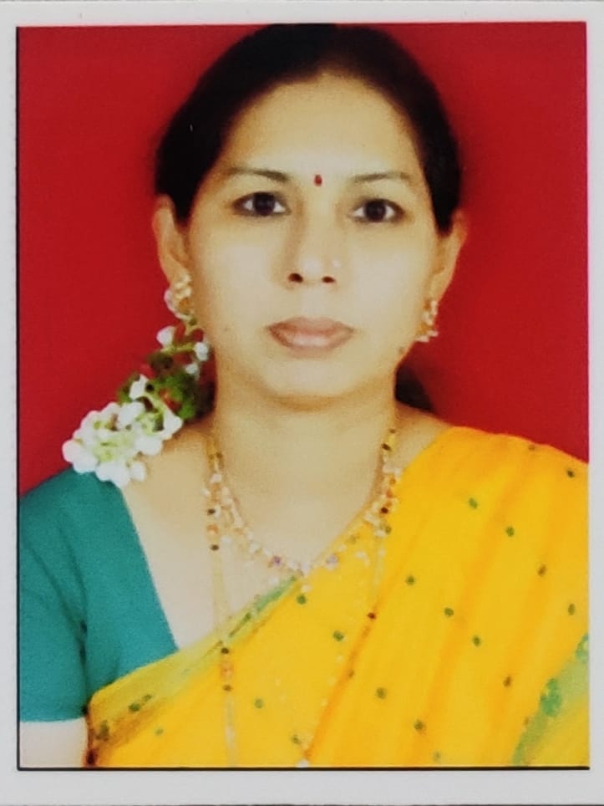
President and Secretary of Student council | Member
Prin. Dr. Arun Andhale | Secretary  Principal, Dr. Babasaheb Ambedkar College, Aundh, Pune-67 | 